CEO Report
Educating the Next Generation

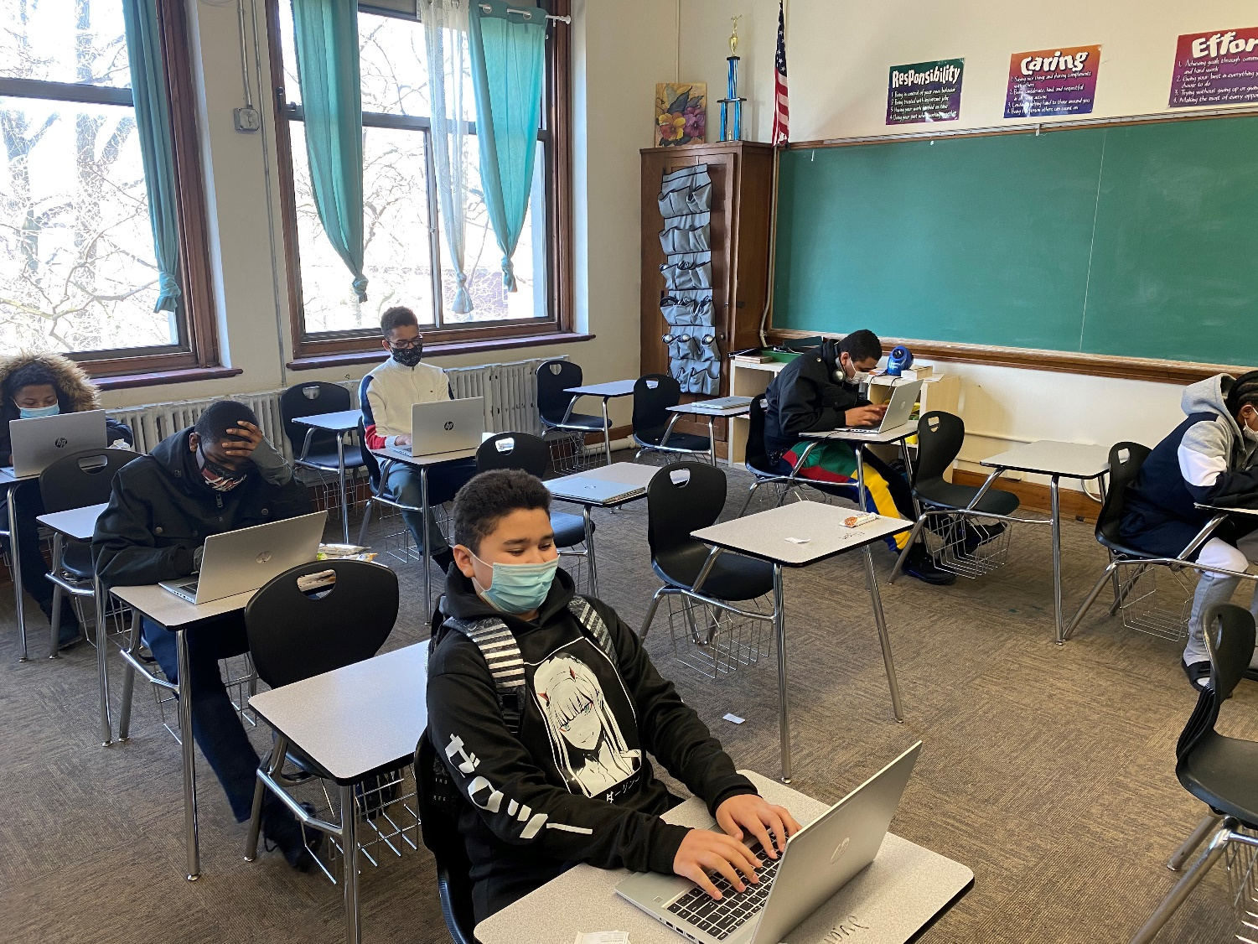
Working towards in-school instruction, overcoming the effects of the Pandemic…

Board of Trustees
Constance Ratcliff Board Chairperson | Ed Williams  Board Vice Chairperson
Wayne Patterson  Board Secretary | Sonya Adams  Board Treasurer
Dr. Margaret Smith | Shantel Hillard
Tim Kuzma | Michael Hooks

March 18, 2021

Table of Contents
- Third- Quarter Report
- Academic Updates
8. Human Resources
8. RFO Report
9. RFO Treasurer’s Report

2020 – 2021 Third-Quarter Report

Third-Quarter Report
The Administration is requesting approval of the revised school calendar to allow for PASA and PSSA testing during the month of June. The proposed end of school will be June 30th. The US Department of Education (USDE) has issued guidance as to how States are to administer assessment testing this year. Due to the pandemic, testing windows have been extended into the fall of 2021. PDE has not at this time requested a waiver of State testing but has informed the USDE that LEAs will be allowed to administer assessments (PASA and PSSA in our case) later in the year. All LEAs have been encouraged to extend the school year, the school day, and use the summer and other methods to compensate for the effects of the pandemic.
The Administration is requesting only a review of the 3i contract as submitted at this time.
The Administration is asking for approval to apply for a second PPP loan. Having talked with the Bank, Rise has been advised to apply by Friday with all of the necessary documentation included. The Bank will determine our eligibility for the loan.
ERLACS Board of Trustees Meeting 3/18/2021

Academic Updates
Erie Rise Leadership Academy charter School

Participation/Attendance Update
Erie Rise Leadership Academy Charter School has been continuously improving its participation/attendance since the first day of school. Due to targeted communication and support efforts, ERLACS has improved its participation/attendance from September to present whole-school.
The teachers and administration will continue to support students and parents/families to the best of their ability to further increase participation/attendance.

Benchmark Assessments
Beginning March 1 through March 12, students in Kindergarten – 8th Grade participated in Benchmark Testing. Homeroom classes were assigned specific days and tested in their classrooms with their teachers while maintaining safe social-distancing. The following assessments were completed by the following grade levels:

Grade | Tests
Kindergarten | DIBELS (reading), EasyCBM (math)
1st Grade | DIBELS (reading), EasyCBM (math)
2nd Grade | DIBELS (reading), EasyCBM (math)
3rd Grade | DIBELS (reading), EasyCBM (reading & math), CDT (PSSA Projection)
4th Grade | EasyCBM (reading & math), CDT (PSSA Projection)
5th Grade | EasyCBM (reading & math), CDT (PSSA Projection)
6th Grade | EasyCBM (reading & math), CDT (PSSA Projection)
7th Grade | EasyCBM (reading & math), CDT (PSSA Projection)
8th Grade | EasyCBM (reading & math), CDT (PSSA Projection)

The administration is currently organizing the benchmark assessment data and will present the results to the Board during next month’s meeting. The results of the benchmark assessments will be used to make decisions relative to interventions and additional resources for our students. Students who are identified as struggling, below grade level, and/or on the cusp of achieving proficiency will be provided with targeted interventions through our Title 1 Program and 21st Century After-School Program.

Read Across America and Diversity Month
During the Month of March, the National Education Association (NEA) celebrates reading and diversity. In the past, Erie Rise has celebrated with our students by reading books, wearing crazy socks, and sporting wild and wacky hair-do's! This year looks a little different though as the pandemic has kept our students at home for nearly a year now. However, we can still celebrate online by encouraging our students to read books each day that celebrate diversity.
All teachers are planning activities and readings throughout this month that expose our students to different cultures and allow them to celebrate diversity and the achievements of those cultures. Erie Rise is an incredibly diverse school, one of the most diverse in Erie County; we are seizing this great opportunity for our students to learn more about the cultures that are represented within our classrooms.
Any classroom that presents their monthly celebrations in some fashion (i.e. a video, skit, PowerPoint presentation, circle read via Zoom, essay/report, etc.) will be entered to win a breakfast or lunch celebration of their choice for their whole classroom once we return to face-to-face instruction.

Professional Development Update
Providing teachers with targeted Professional Development opportunities allows them to improve their knowledge and skills which in turn should lead to school-wide improvement, mainly increased student achievement. ERLACS teachers have participated or will participate in the following PD Sessions:

Gale online e-Library | Completed 1/15
Family Engagement | Completed 2/5
Social Emotional Learning | Completed 2/12
Teaching with Poverty in Mind | Completed 2/12
Trauma-Informed Education | Completed 2/19
Universal Design for Learning (UDL) | Completed 2/26
Technology and Other Resources for the Online Classroom | Scheduled for 3/12
Teaching with Poverty in Mind II – Brain Research & Practical Application | Scheduled for 3/12
Restorative Practice and Positive Behavior Intervention Systems | Scheduled for 3/12
PSSA Training | Scheduled for 3/12
Engaging Students in the Online Classroom | TBD
Response to Intervention (RTI) | TBD
Co-Teaching | TBD

Human Resources/Compliance Report
March 18, 2021
Human Resources is seeking to fill the following position:
Security | Ms. Amanee Mateen
Classroom Aide | Ms. Darrellesha Williams
Maintenance | Ms. Gwendolyn Jones
Maintenance | Ms. Wendy Huff
Cafeteria/Lead | Ms. Zabrina Thompson
Cafeteria | Mr. Dylan Malinowski
Security/Systems Manager | Mr. Da’Joun Heidelberg
Bus Driver | Mr. Derek White (replacing: Richard Rondeau)

Erie Rise Leadership Academy Charter School
Rise Family Organization Update.
March 18, 2021

Special Programs/Activities:

- The Title I Program conducted K-8 grade level assessments, March 2 – March 12, 2021.
- The RFO is encouraging Families, Teachers, Board Members and the Administration to submit Box Tops to the Rise Office.
- The Erie Rise Title I program will be participating in a virtual Families Turn on to Literacy workshop between January – April 2021 courtesy of a grant from WQLN.
- The RFO in conjunction with the Board of Trustees will award (2) Erie Rise Alumni Scholarships. The scholarship is available to Erie Rise graduates (Class of 2017) who will be graduating from High School in 2021. The Erie Rise Alumni Scholarship is one of the scholarships available through the My Brother’s Keeper Scholarship application. Deadline for applications is Amy 1, 2021.
- Tentative plans to host a Special Zoom RFO Parent meeting on Tuesday, March 30, 2021 at 7:00 p.m.

Upcoming Events

- Box Top
- Tentative Special Zoom RFO Parent Meeting on March 30, 3021 at 7:00 p.m.
- Deadline for the 2nd Annual Erie Rise Alumni Scholarship is May 1, 2021.

 | Erie Rise-Rise Family Organization Treasurer's Report |  |  |  |  |  |  | 3/8/2021
 |  | Savings Account
begining Balance as of 2/8/21 |  |  |  |  |  |  | $2,537.98
2/28/2021 |  | Dividend |  |  | $0.19
Ending Balance |  |  |  |  |  |  | $2,538.17
3/8/2021
 | Erie-Rise Family Organization Treasurer's Report
 |  | Checking Account
Beginning Balance |  |  |  |  |  |  | $2,880.83
2/8/2021
Funds Received:
Expenses:
Ending Balance |  |  |  |  |  |  | $2,880.83
3/8/2021

