CEO Report
Educating the Next Generation

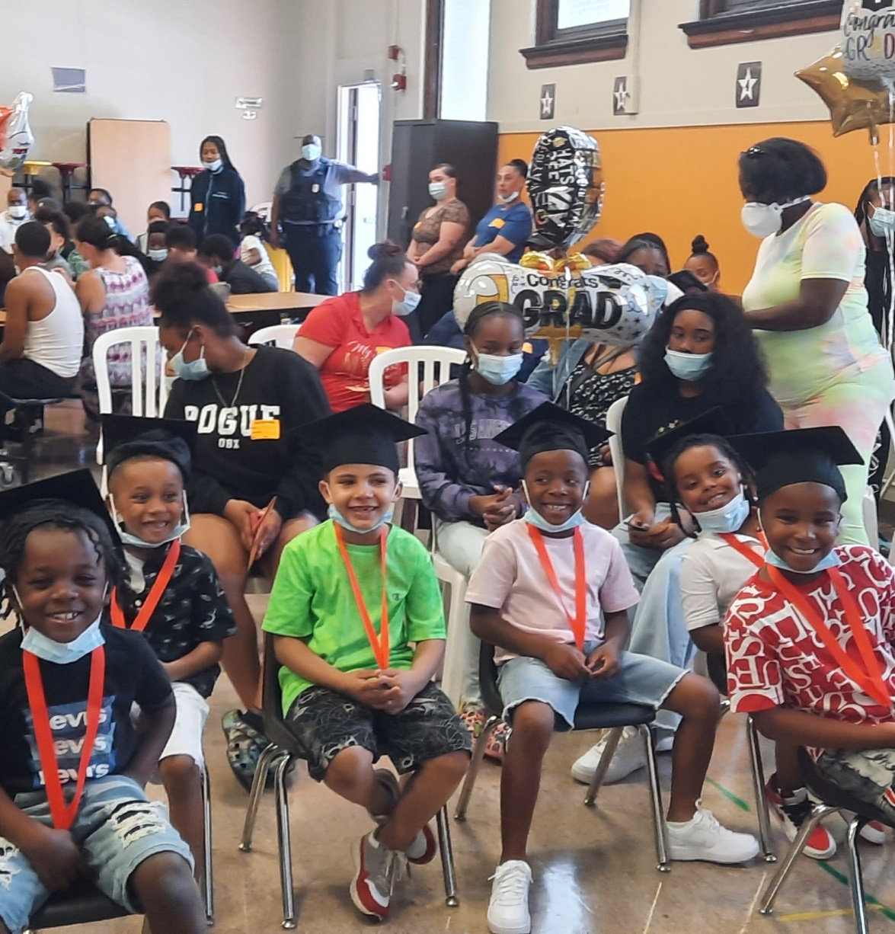
The 10th was Kindergarten graduation time; great things are happening at Erie Rise.

Board of Trustees

Dr. Margaret Smith  Board Chairperson | Ed Williams  Vice-Chairperson
Constance Ratcliff Board Secretary | Shantel Hilliard
 | Michael Hooks

June 16, 2022

Table of Contents
3. Current Business Activity
5. Educational Leader's Report
8. Human Resources Report

Current Business Activity (5/19 – 6/16)

The June Board meeting marks the end of the fourth quarter (June 15) and the end of school (June 16). The 2021-22 school year closes with the eighth-grade graduation at the Blasco Library (Hirt Auditorium) starting at 4 pm.

Erie Rise will send four staff from the school, one board member, and our attorney to the National Charter School Conference in Washington, D.C., on June 19 – 22. The focus of this year's conference will be around three areas:
- COVID's Impact on Learning Outcomes and Mental Health
- The Future of Teaching, Education, and Charter Schools
- Building Diverse and Engaged Advocates

This year's conference will mark our first in-person meeting after two years of virtual meetings. The conference will open Sunday the 19th with a welcome reception from 7 pm to 9 pm. Sessions Monday and Tuesday will run from 8 am to 4 pm. Wednesday's closeout sessions will run from 8 am to 12:30 pm. This year's conference will offer a mix of 60-minute sessions and 90-minute workshops on critical topics for charter schools and address the changing needs of public education.

Erie Rise, as a Nita M. Lowey 21st Century Community Learning Center, was required to develop and submit a formal, written emergency readiness plan using the template provided by the State. Ms. Bridgett sent in a revised plan on 6/2/22 (an attached copy is available for the Board and Attorney with this report).

The plan's purpose is to have a pre-arranged system to prevent, prepare, respond, and recover from emergencies caused by natural disasters and human-caused events such as violent incidents or accidents that affect others.

Rise is proud of its excellent safety record and the great work done by the nurses (Ms. Dent and Ms. Joyce), Ms. Hooks (cleaning services), and Mr. Boose (building maintenance). The Nurse's office re-implemented indoor mask-wearing as of 5/23/22 due to rising COVID-19 cases in Erie County. The Nurse's office is working closely with HR to take preventive measures (mask-wearing, hand hygiene, and cleaning of high-touch surfaces in high-traffic areas of the school) to mitigate the spread of COVID-19.

Erie Rise was honored to have a visit by Mr. Neal Brokman (ESD Executive Director of Operations) on June 3rd. He spoke with Board Personnel, Michael Hooks, Principal Krakoff, and myself. He also took our busing contracts (for the last two years), so they could be submitted for payment.

Dr. Smith signed off on renewals of the CSIU data services system (see attached agreements).

Erie Rise is in contact with a company in James Town concerning school uniforms and will provide further information on uniforms.

Erie Rise shot its first commercial for the upcoming school year on June 6th. Copies of our new enrollment Bill Board ad and flyers are attached for the Board's convenience.

We have invited Ms. Lesha Powell, Satellite Branch Director of Bethany Christian of Western PA, to discuss Teacher and Parent training on dealing with behavioral issues at school and home.

A copy of the school's enrollment contract is attached to this report for board review. Details regarding the school's new safety protocol will be sent to the Board by June 30th, outlining the new safety measures that are being worked on for the upcoming school year. A detailed report will be sent to the Board through the Board personnel person (Michael Hooks). Plans will cover metal detection, improved camera coverage, student and personnel tracking in and around the building, and other safety measures for the new school year.

At the end of the school year our teachers and our title 1 coaches conducted internal testing as follows:
- easyCBM Math K-8 completed in May
- easyCBM Reading 4-8 and Dibels K-3 was completed in May
- CDT Math & ELA 3-8 was completed June 1-3rd

The Principal will share details concerning our results.

Educational Director’s Report June 2022

Academic Report
Applying the Easy Curriculum Based Measurements( CBM) data, which is based on assessments aligned to national Common Core Standards, and DIBELS, which measures reading comprehension in grades K-3, here is a breakdown of our results and growth at ERLACS:
K-3 Showed Significant Growth on DIBELS:
- Word usage fluency in kindergarten grew from 10 words per minute to 27 from fall to spring assessment.
- First-grade students’ correct letter sounds per minute increased from 14 to 34.
- Third-grade students’ oral fluency increased from 62 words per minute to 80.
CBM
- Math data for kindergarten students showed an increase from 58% accuracy to 74% between fall and spring.
- Math data for first-grade students showed an increase from 46% accuracy to 58% between fall spring.
- Math data for second-grade students showed an increase from 36% accuracy to 58% between fall and spring.
- Math data for third-grade students showed an increase from 62% accuracy to 67% between fall and spring.
- Math data for fourth-grade students showed a decrease from 51% to 49% between fall and spring. Out of three reading areas, two decreased in percentage from fall to spring.
- Math for fifth-grade students showed an increase from 47% accuracy to 51% between fall and spring. Two out of three reading areas revealed no increase and the third showed a modest improvement.
- Math for sixth-grade students showed an increase from 49% accuracy to 51% between fall and spring. Out of the three reading areas, two showed no increase and one showed modest increase.
- Math for seventh-grade students showed no increase between fall and spring. Out of three reading areas, no increase was revealed in two of three areas and a modest increase was shown in the third.
- Math for eighth-grade students showed no increase between fall and spring. Out of three
reading areas, two of three areas decreased and one showed modest growth.

Student Discipline Report

Student Incident Reports by Month Reflect that New System Implemented in February is Taking Effect
February - 436
March - 976
April 537
May 581
June 179

Out of School Suspension Summary January - June 2022
- 119 Total OSS events
- OSS events by grade level. In total, 85.7% of OSS events occurred in grades 4-8. :
K - 8
1st - 1
2nd - 5
3rd - 3
4th - 25
5th - 19
6th - 22
7th - 16
8th - 20

Restorative Practices Proving Effective
● A total of 87 students have been assigned out-of-school suspension between February -
June 2022 or 24% of our student population. Of those 87, only 23 had to be assigned OSS for more than one event, or 6.3% of our student population. As for repeat rate,
73.5% of students who received an OSS did not repeat an OSS level behavior.

Kindergarten Graduation Success
We held our kindergarten graduation on Friday, June 10th. We welcomed a standing-room only crowd as we celebrated our kindergarteners’ promotion to first grade.

Partnership with Mercyhurst University
We want to thank Mr. Hilliard for his facilitation of a developing partnership. Mercyhurst representatives have visited our campus both during the school day and during our 21st Century after-school program and we are in the process of finalizing an agreement for our partnership. This partnership is being designed to support the redesign of our 21st Century after-school program to support our instructional system during the day while also providing scholars with social emotional supports. Harlem Children’s Zone
We have made contact with and discussed plans for a team of our school’s administration and lead teachers to visit Harlem Childrens’ Zone. The purpose of this visit will be for our team to tour the Harlem Childrens’ Zone’s facilities and learn about the systems that their organization has designed and implemented to flourished in the Harlem community. We are in the process of scheduling this visit for the fall of 2022.
CBM Comparison Between Spring of 2021 and Spring of 2022 - Low Risk Percentages

Grade and Subject | Spring 2021 Low Risk % | Spring 2022 Low Risk %
Grade 4 Math | 13% | 13%
Grade 4 ELA | 21% | 22%
Grade 5 Math | 8% | 11%
Grade 5 ELA | 14% | 14%
Grade 6 Math | 16% | 49%
Grade 6 ELA | 19% | 47%
Grade 7 Math | 19% | 25%
Grade 7 ELA | 15% | 40%
Grade 8 Math | 10% | 29%
Grade 8 ELA | 10% | 25%

April 21, 2022
Human Resources/Compliance Report
Human Resources is currently reviewing candidates to fill needed openings and will pass
on that information when available.

Human Resources is requesting approval of the following candidates:
- Ms. Chrissy Barr – Social Worker
- Michael A. English, Sr – K- 4 Principal
- Elysla Cmiel – Teacher

